**LITERATURE REVIEW**

**2.1 INTRODUCTION**

This will provide a review about the previous research and existing project that have been made by using reference sources and guidelines as journals, internet, article writing, blog and scientific studies to get an idea about the project design, conception and any information that related to improve the project. With a differences concept and design, there are other creation and innovation of projects done by the other people. The research that is related to this project also covered in this chapter.

**2.2 WHAT IS GAS LEAKAGE MONITORING AND ALERTING SYSTEM?**

The literature review of the papers that were referenced and those that serves as base paper and supporting paper provides a detailed description about the state of the implementation of Gas leakage monitoring and alerting system. This literature review outlines the impact of Gas leakage monitoring and alerting system for the industries to prevent the leakage of gas. The inflammable gas such as Liquidized petroleum gas (LPG), which is excessively used in the house and at work places. The leakage of the gas causes destructible impact to the lives and as well as to the heritage of the people. So, by keeping it in the concept of the project we have determined to develop an examining system which finds the leak of LPG gas and protects the work places by taken correct precaution at correct time.

**2.3 AUTHORS AND THEIR PROPOSAL**

**A. LIU zhen-ya, WANG Zhen-dong and CHEN Rong**

In the year of 2008, LIU zhen-ya, WANG Zhen-dong and CHEN Rong, “Intelligent Residential Security Alarm and Remote Control System Based On Single Chip Computer”, the paper focuses on, Intelligent residential burglar alarm, emergency alarm, fire alarm, toxic gas leakage remote automatic sound alarm and remote control system, which is based on 89c51 single chipcomputer. The system can perform an automatic alarm, which calls the police hotline number automatically. It can also be a voice alarm and shows alarm occurred address. This intelligent security system can be used control the electrical power remotely through telephone.

**B. Chen Peijiang and Jiang Xuehhua**

In the year of 2008, Chen Peijiang and Jiang Xuehhua, “Design and implementation of Remote Monitoring System Based on GSM”, this paper focuses on the wireless monitoring system, because the wireless remote monitoring system has more applications a remote monitoring system based on SMS through GSM.

**C. K.Galatsis, W.Wlodarsla, K.Kalantar-Zadeh and A.Trinchi**

In the year of 2002, K. Galatsis, W. Wlodarsla, K. Kalantar-Zadeh and A.Trinchi,“Investigation of gas sensors for vehicle cabin air quality monitoring”, this paper focuses on, car cabin air quality monitoring can be effectively analyzed using metal oxide semiconducting (MOS) gas sensors. In this paper, commercially available gas sensors are compared with fabricated Moo3 based sensors possessed comparable gas sensing properties. The sensor has response 74% higher relative to the hest commercial sensor tested.

**D. Somashekhar Malipatil, Shilpa, Jayasudha**

In the past, There are lot of authors came up with ideas to prevent and detect gas leakage such as, The authors Somashekhar Malipatil, Shilpa, Jayasudha proposed LPG Gas Measurement Detection using GPS. They used components like Arduino, LPG, GPS, MQ6 sensor, Load cell,Signal amplifier. This system monitors the level of gas cylinder. If threshold level comes below 2kgs the alert SMS will be sent to the user and also it detects the leakage level.

**E. Siddharth, Rameswari, Keerthana Gayathri, Kavin Sanjaya**

Siddharth, Rameswari, Keerthana Gayathri, Kavin Sanjaya proposed Smart gas assistant for a perfect kitchen. In this paper they used Arudino, Wi-Fi, GSM Module, Internet of Things, Online Tool, Mobile Application. This system measures the amount of LPG present in the cylinder. It automatically books the cylinder from registered number. And a alert message sent to the customer also about volume of gas available in cylinder.

**F. Anusha, Nagesh, Venkata Sai, Srikanth, Rupalin Nanda**

Anusha, Nagesh, Venkata Sai, Srikanth, Rupalin Nanda designed IoT Based LPG Leakage Detection and Booking System with Customer SMS Alerts. In this paper they used GSM Modem, MQ2 Gas Sensor, Load Cell, AWS server. This system automatically detect the fuel leak and alert the user by sending the sms. If user is busy somewhere and fails to respond on time it automatically reserves the characteristics of LPG gasoline and replaces the data of reservation on the server robotically by using AWS server.

**PROPOSED SYSTEMS**

This proposed system provides a way to detect leaks using a gas sensor MQ6 the detection system, Arduino, ESP8266 and alert system. Below diagram shows architecture of gas leakage detection in which Arduino has used to get input from gas sensor then give signal to stepper motor to turn off the valve of cylinder. And alert neighbour by turning buzzer and exhaust fan on. Also, sms the owner including images using Esp8266.

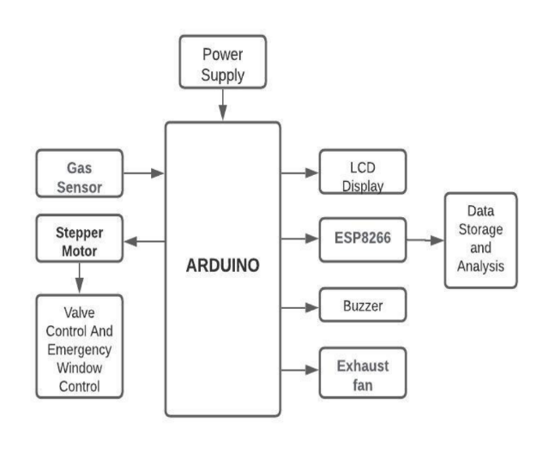

**IMPLEMENTATION**

IoT-based intelligent (LPG) leakage detector project is implemented using an ESP8266 chip. The circuit diagram shown below in image. MQ6 gas sensor has given input to Arduino which after detection of leakage action will be taken. The output will be displayed on IOT based display about the gas level shown in fig.4, which will show the percentage of gas level as per set value. If leakage is detected stepper motor will be informed to turn on the valve simultaneously buzzer will be turned on till user turns off after getting sms about the leakage.

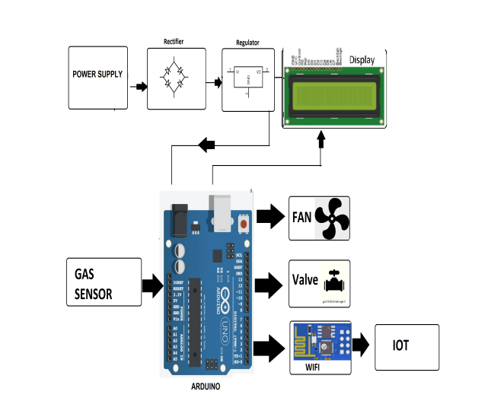

**FLOWCHART**

Below Flow chart shows how much gas present in the air. In starting if gas leaks it will be detected by the sensor and check the threshold value. As per result it turn on the motor and cylinder valve will be closed if still threshold is lower than gas value then alert message will be sent to the fire station and power will shut automatically. And even user will get the alert message immediately to act as per.

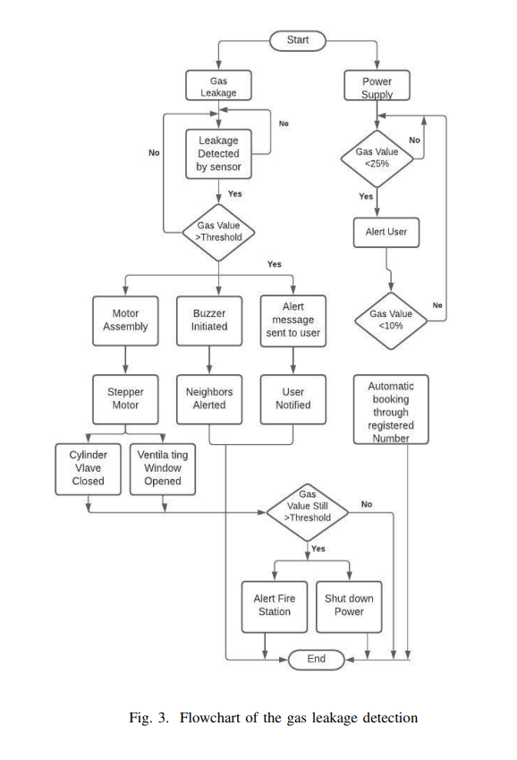

**INFERENCE OF LITERATURE SURVEY**

The literature review of the papers that were referenced and those that serve as base paper and supporting paper helped to narrow down the main challenges that the proposed application might face. Also, it has served as a guide for the development of the application in the right way, using the necessary tools. From the Table 2.2, the following were inferred from the literature survey.

**Table: Inference of the Literature Survey**

|  |  |
| --- | --- |
| **AUTHOR NAME** | **INFERENCE** |
| LIU zhen-ya, WANG Zhen-dong and CHEN Rong | Intelligent Residential Security Alarm and Remote Control System Based On Single Chip Computer |
| Chen Peijiang and Jiang Xuehhua | Design and implementation of Remote Monitoring System Based on GSM |
| K.Galatsis, W. Wlodarsla, K. Kalantar-Zadeh and A.Trinchi | Investigation of gas sensors for vehicle cabin air quality monitoring |
| Somashekhar Malipatil, Shilpa, Jayasudha | LPG Gas Measurement Detection using GPS. They used components like Arduino, LPG, GPS, MQ6 sensor, Load cell,Signal amplifier. |
| Siddharth, Rameswari, Keerthana Gayathri,  Kavin Sanjaya | Smart gas assistant for a perfect kitchen. In this paper they used Arduino, Wi-Fi, GSM Module, Internet of Things, Online Tool, Mobile application. |
| Anusha, Nagesh, Venkata Sai, Srikanth,  Rupalin Nanda | IoT Based LPG Leakage Detection and Booking System with Customer SMS Alerts. In this paper they used GSM Modem, MQ2 Gas Sensor, Load Cell, AWS server. |